The list below shows planned closures and detours as part of highway, rail, bike, pedestrian, and lagoon improvement projects. Detour signs will be placed, as needed, to assist motorists through closures. Please note, these closures are subject to change.

Week of February 28

HIGHWAY
- Residents and motorists should expect intermittent nighttime construction noise, lane closures, and ramp closures along I-5 between Lomas Santa Fe Drive in Solana Beach and Palomar Airport Road in Carlsbad from Sunday, February 28, through Thursday, March 4, from 9 p.m. – 5 a.m. for roadway excavation, earthwork hauling and placement, drainage installation, and maintenance.

- Residents and motorists should expect intermittent nighttime construction noise, lane closures, and ramp closures along Manchester Avenue at I-5 from Sunday, February 28, through Friday, March 5, from 9 p.m. – 5 a.m. for bridge foundation and bridge column work, and roadway restriping.

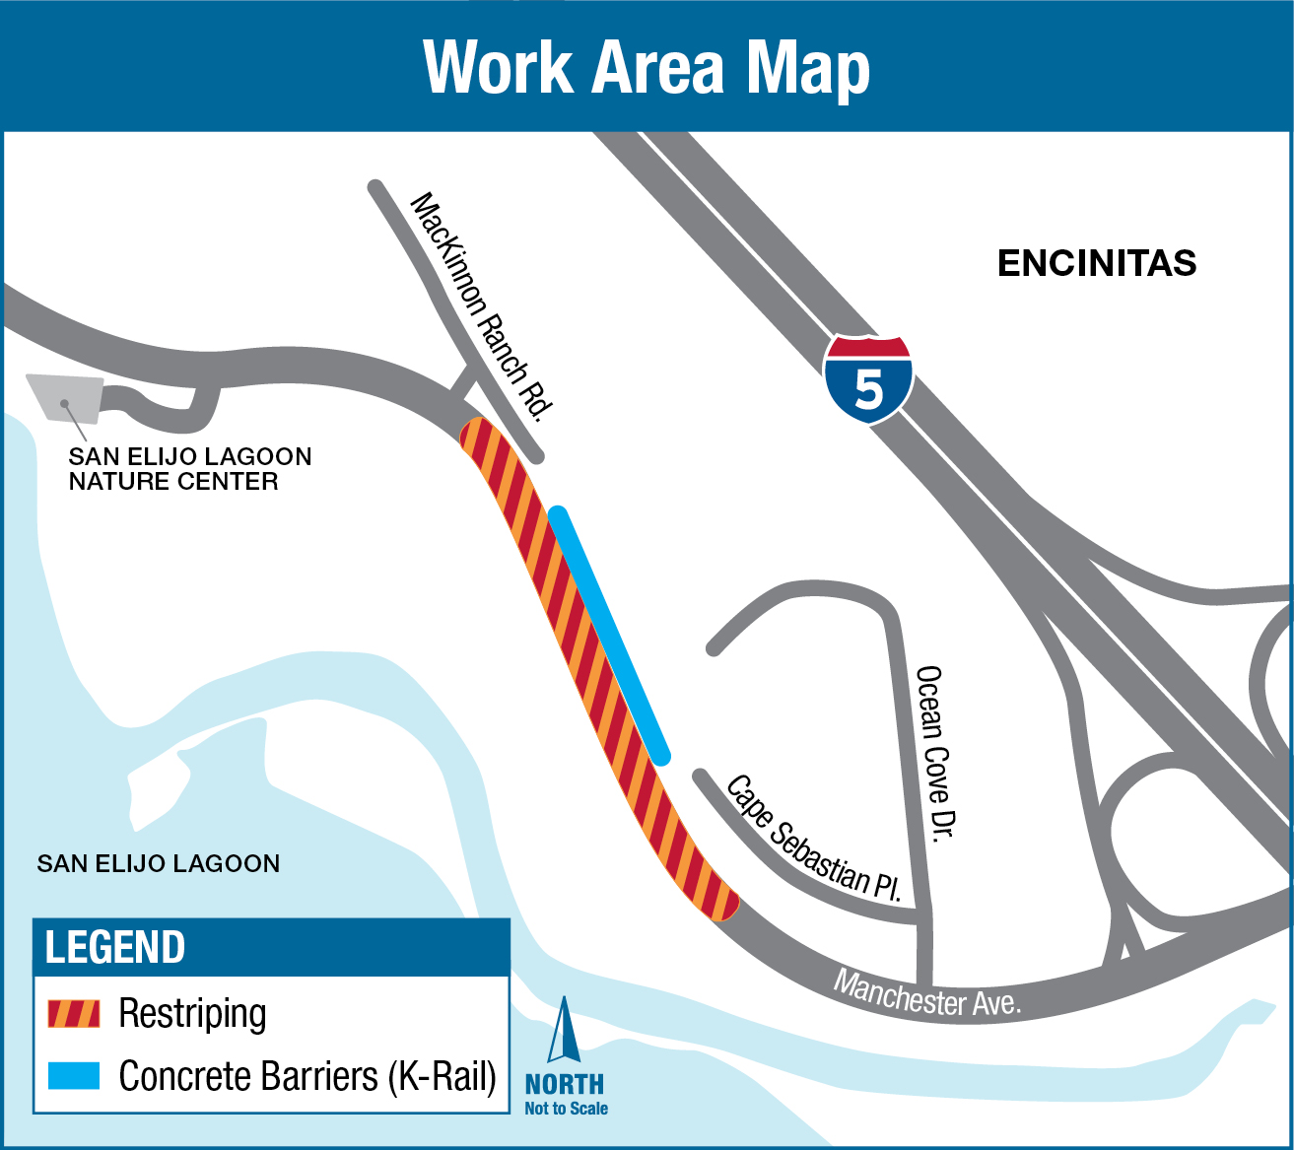

- Residents and motorists should expect intermittent daytime construction noise, flagging operations, and reduced lane widths along Manchester Avenue at I-5 from Monday, March 1, through Friday, March 5, from 7 a.m. – 5 p.m. for bridge foundation and bridge column work, and utility installation.

- Residents and businesses should expect intermittent daytime construction noise along I-5 between Lomas Santa Fe Drive in Solana Beach and Palomar Airport Road in Carlsbad from Monday, March 1, through Friday, March 5, from 7 a.m. – 5 p.m. for roadway excavation, roadway paving, earthwork hauling and placement, drainage and electrical infrastructure installation, and embankment construction.

LAGOON/BIKE/PEDESTRIAN
- Residents and businesses along N. Rios Avenue in Solana Beach and Manchester Avenue in Encinitas can expect an increase in vehicle and equipment traffic as well as general vehicle noise and back-up alarms from Monday, March 1, through Friday, March 5, from 7 a.m. – 5 p.m. for transport and hauling of dirt, equipment, plants, and other materials to and from the San Elijo Lagoon.

- To view current San Elijo Lagoon trail closures please visit thenaturecollective.org/trails. For information on the San Elijo Lagoon Restoration project, please visit thenaturecollective.org/project/san-elijo-lagoon-restoration.

Sign up for project updates at KeepSanDiegoMoving.com/BuildNCC, or text BuildNCC to 313131 to receive construction alerts. For questions, please call 844-NCC-0050.

